Generative AI (GenAI) and Edge AI (or hybrid edge-cloud AI)
Architecture
These diagrams illustrate how Generative AI (GenAI) and Edge AI (or hybrid edge-cloud AI) can be integrated — plus when each kind of diagram is useful (e.g. high-level architecture, data flow, hybrid deployment, etc.).

Recommended Diagrams for GenAI + Edge-AI Integration
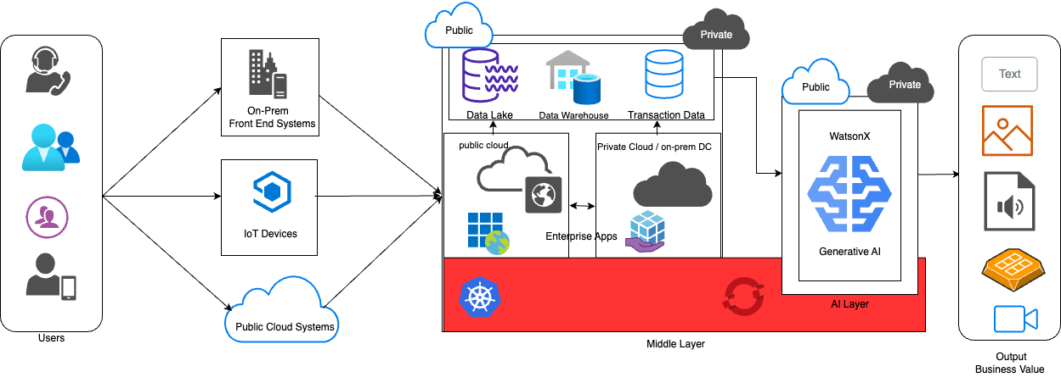
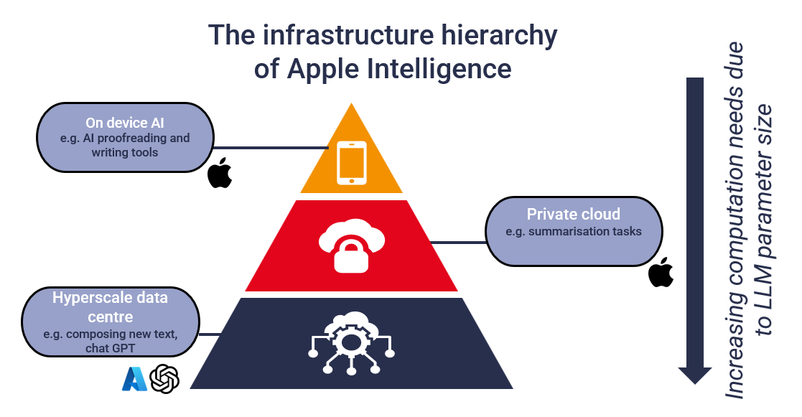
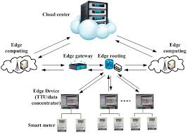
See other diagrams of Architecture (1-8)
What these diagrams show
- Hybrid / hybrid-cloud–edge GenAI architecture — e.g. on-device (edge) handling of lighter inference or preprocessing, with heavier LLM-based generation in the cloud. This is often represented by a split between “edge device / gateway / local compute” and “cloud servers / central AI infrastructure.” https://stlpartners.com/articles/edge-computing/edge-gen-ai-new-chapter-for-gen-ai/
- Edge-AI / IoT-edge architectures — diagrams showing how sensors or IoT devices feed data to edge compute nodes for preprocessing or inference, reducing latency and network load. https://www.researchgate.net/figure/Architecture-diagram-of-the-AI-oriented-edge-computing-system_fig2_381796127
- Enterprise GenAI + ML pipelines — architecture diagrams from enterprise-oriented blueprints that include data ingestion, storage, model training/serving, deployment layers, and monitoring. Useful when GenAI is part of a larger ML stack. https://docs.cloud.google.com/architecture/blueprints/genai-mlops-blueprint
- Edge-to-Cloud Data Flow for GenAI — showing how raw or sensor data from edge devices are ingested, processed, possibly embedded or transformed at the edge, then sent (or selectively sent) to cloud-based generative models for final inference.
This pattern is especially relevant when combining Edge AI’s real-time/data-localization strengths with GenAI’s heavy compute needs. https://d197for5662m48.cloudfront.net/documents/publicationstatus/269533/preprint_pdf/896d9cfc5a581565b35c142be4c2dbde.pdf

When to Use Which Diagram Style
Use-Case / Goal | Best Diagram Type
High-level overview to stakeholders (non-technical) about “where AI runs” (edge vs cloud) | Hybrid Edge-Cloud GenAI architecture diagram (first type above)
Real-time / latency-sensitive applications (IoT, robotics, edge sensors) | Edge-AI / IoT-Edge architectures
Enterprise-scale deployment: data ingestion, governance, ML/AI model lifecycle | Enterprise GenAI / ML pipeline diagrams
Mixed workloads: combination of local preprocessing + centralized generative processing | Edge-to-Cloud GenAI Data Flow diagrams

Why These Diagrams Are Useful — What Makes Them “Best”
- They visually separate concerns: cloud vs edge vs client — which clarifies trade offs (latency, privacy, resource usage).
- They map data flow & decision boundaries, helping architects/designers’ reason about where data resides, what’s processed locally vs remotely.
- They are adaptable: you can annotate them to reflect real-world constraints (bandwidth limits, regulatory zones, offline requirements, etc.).
- They scale with complexity — whether you need a simple user-facing diagram or a detailed enterprise-level ML/AI stack.

Recommendation
While building or designing a system that uses both GenAI and Edge AI, start with a hybrid edge-cloud GenAI architecture diagram (like the first image above) to align stakeholders.
Once higher-level design is agreed, expand into a detailed Edge-to-Cloud Data Flow or Enterprise ML/GenAI pipeline to nail down data handling, model serving, and deployment logistics.

